Early Electronic Warfare Aircraft Crash Site Found at Closed Naval Air Station
By David Trojan
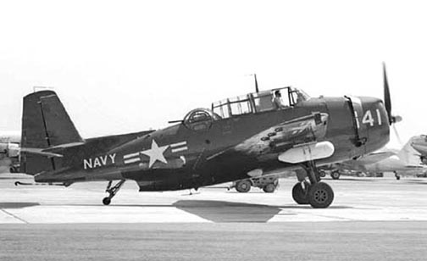
Grumman / General Motors TBM-3Q Avenger
The TBM-3 Avenger had a noteworthy career with the US Navy during World War Two. However, the end of World War II did not bring to a halt the career of the famous aircraft. The Avenger had the strength and power to do other important jobs. The TBM-3 Avenger still had valuable service to offer during the difficult postwar years. The major operational version in US Navy service at the time was the TBM-3E. After the war the TBM-3E carried advanced radar equipment for the search and location of submarines. It is in this area of activity that the Avengers were used extensively until the introduction into service of newly developed and highly specialized aircraft. The TBM-3E was developed into a TBM-3Q for use as one of the first electronic countermeasures aircraft. TBM-3Qs were used against enemy radar emitters. Of the approximately 9,800 Avengers built by Grumman and General Motors, at least 50 TBM-3Es were modified into TBM-3Qs. The new “Q for electronic countermeasures” designation was authorized by Bureau of Aeronautics in 1946, with the Avenger being the first to use the new subtitle.
Airborne Electronic Warfare (EW) first took off with the advent of Radar in WWII. This single invention made it possible to detect air raids and vector in interceptors to incoming bombers. As with any form of warfare, the enemy soon developed countermeasures and a race toward more advanced radars began. Electronic countermeasures or (ECM) were developed to deny the use and advantage of the use of the electromagnetic spectrum. In simpler terms ECM is a complex and technological game of ping-pong, with one side trying to outdo the other. Due to the advent of nuclear deterrence in post WWII a lot of emphasis was placed on the development of more powerful and sensitive radar equipment. Correspondingly, a greater stress was placed on developing and acquiring the ability to defeat these systems. In the years following WWII these advanced systems and the platforms that accommodated them found their way into various air forces across the world. The `Electronic War’ soon became a common theme in most conflicts in the world.
The TBM-3Q was equipped with APS-4 radar that was prominent beneath the starboard wing. Other hard-to-spot items included stub antennae on the bomb bay doors, and the yagi direction finder forward of what once had been the ventral gun position. At least nine VT/VA squadrons deployed with this type of aircraft to the Western Pacific and Mediterranean. Each of ten aircraft carriers had an initial allowance of 15 TBM-3Es and 5 TBM-3Qs. These aircraft retained some ordnance delivery capability while also providing basic airborne electronic countermeasures for the air group.
TBM-3Q number 91350 rests in the terrain of the now closed NAS Barbers Point covered with scrub trees. Aircraft number 91350 was assigned to Fleet All Weather Training Unit Pacific (FAWTUPAC). The aircraft crashed at about nine o’clock on the morning of 17 September 1948 during a routine training mission. A flight of four TBM’s was cleared for takeoff on the right side of runway four at Barber’s Point. Aircraft number 91350 was the fourth aircraft to take off.
Aircraft 91350 was making a right turn out of the traffic pattern as directed when the trouble started soon after take off. The aircraft made a gentle-right climbing turn. When opposite the upwind end of runway four, at an altitude of approx. 200 feet, the aircraft entered a violent, right wing down climb. At this time the aircraft commenced to skid. The aircraft continued to climb to a maximum altitude of 480 feet until it rolled over to the right and became inverted. Then the nose of the inverted aircraft dropped and the aircraft crashed into the ground at about 160 knots per hour bursting into flames. All occupants were killed by impact or fire. The three aircrewmen that perished in the accident were Pilot Ensign Warren Webster, AMC Bert Taylor and Airman Alvin Seeley JR.
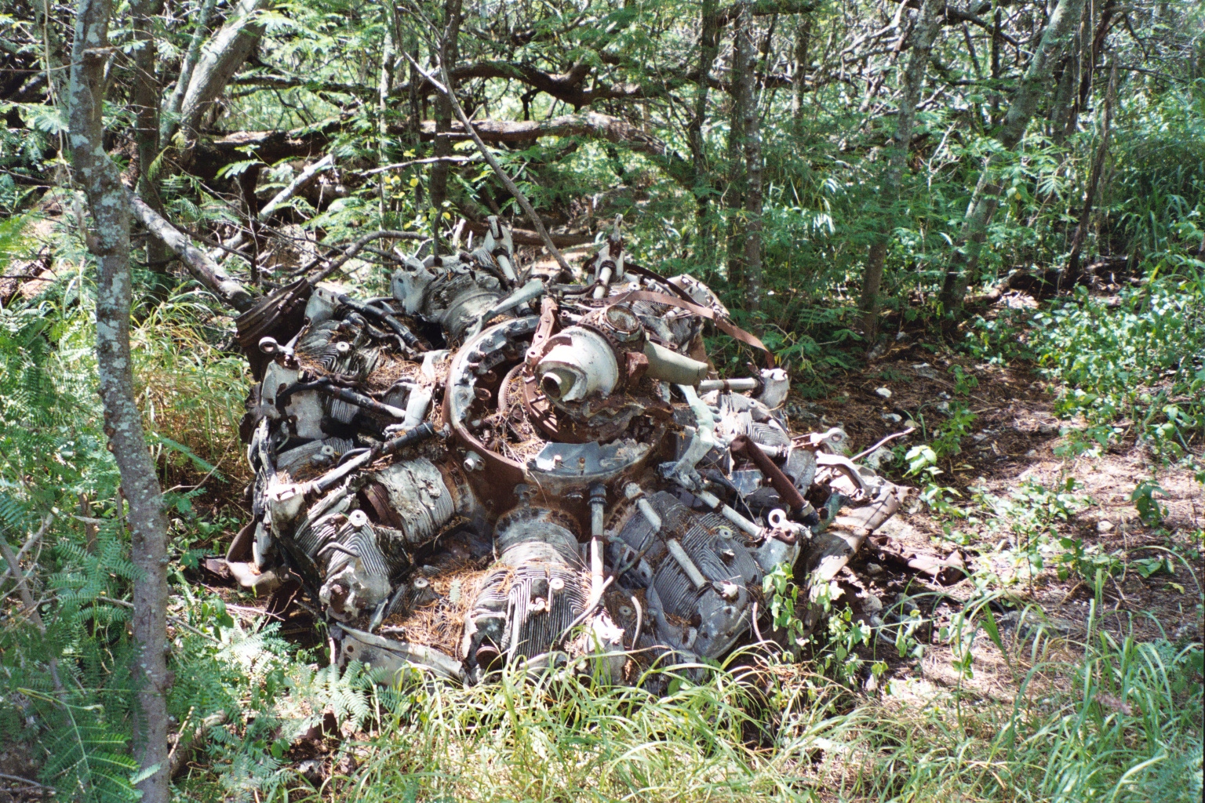
Wright R-2600-20 Cyclone 14-cylinder radial engine

An exhaustive investigation of the wreckage was made in an effort to establish the cause of the accident. No evidence of material failure or improper weight and balance conditions was found to have contributed to the accident. All other TBM’s in the squadron were inspected for faulty control operations and none were found. Because of the nature of the accident and the resulting condition of the aircraft it was impossible to assign specific error to the pilot or other persons.
The remains of the aircraft rest peacefully in the landscape surrounded by bushes and trees. The once powerful Wright R-2600-20 Cyclone 14-cylinder radial engine lies on its back. Most of the aircraft has long since disappeared. Some small-scattered parts remain as a testimony to the brave crew that flew in the aircraft.
The TBM-3Q was rapidly replaced by the Douglas Sky raider’s “Q” family beginning in 1948 and the TBM-3Q disappeared from fleet service soon afterward to be assigned to a variety of land-based outfits. By 1955 the 47 survivingTBM-3Qs were relegated to storage at Litchfield Park near Phoenix, Arizona. Large numbers of TBM-3 Avengers found postwar roles with Canada, France, Japan and the Netherlands. Even after their retirement from military service, Avengers continued to do aerial battle with forest fires and agricultural pests into the 1980s. Their cavernous fuselage and good weight lifting ability kept them busy in these roles until the cost of spare parts and engine overhauls made them uneconomic. The TBM-3Q played a brief but important part in the history of Electronic Warfare.

Specifications
Type: Three Seat Carrier Based Torpedo Bomber
Manufacturer: Grumman Aircraft Engineering Corporation and the Eastern Division of General Motors
TBM-3: One 1,750 hp, Wright R-2600-20 Cyclone 14-cylinder radial engine.
Performance: Maximum speed 267 mph at 15,000 ft; cruising speed 147 mph; service ceiling 23,400 ft.
Range: 1,130 miles on internal fuel.
Weight: Empty 10,700 lbs with a maximum take-off weight of 18,250 lbs.
Dimensions: Span 54’ 2”; length 40’; height 16’ 5”; wing area 490 sq ft.
Armament: Two forward firing 50 cal. machine guns, one 50 cal. machine gun in dorsal turret and one 30 cal. gun in ventral position, plus up to 2,000 lbs of weapons including a 22 inch torpedo in bomb bay and provisions for rocket projectiles, drop tanks or a radar pod under the wing.

