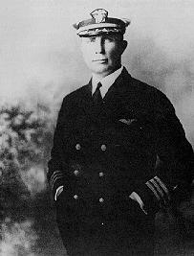

John Rodgers Odyssey to Hawaii

By Dave Trojan
In 1924 Rear Admiral William E. Moffett, head of Bureau of Aeronautics, decided that the Navy needed a sensational event to convince the public that naval aviation had unique requirements that could only be met if the Fleet maintained an integral air arm. It was decided that a suitable demonstration of the Navy’s requirements would be a non-stop flight from San Francisco to Honolulu. In 1925 the Navy turned to the commander of the Naval Air Station at Pearl Harbor, Commander John Rodgers. John Rodgers was the second Naval Officer in history to qualify as a Naval Aviator. This flight would provide an important breakthrough, the first flight across any significant portion of the Pacific Ocean. A San Francisco to Honolulu crossing would cover about 2100 nautical miles, a distance a bit farther than that across the Atlantic between the northeast coast of North America and Europe. A long transoceanic flight would also provide a test of how far the state of the art had advanced in flying boats.
John Rodgers decided on a mass flight of three flying boats, the Naval Aircraft Factory PN-9-1 (A-6878) and PN-9-3 (A-6799), and an experimental Boeing model called the PB-1. Though each of the PN-9s were prototypes and test airplanes, some did serve in Navy squadrons. The PN-9 flying boats were constructed with newly redesigned tail surfaces and aluminum alloy hulls. They also had revised engine nacelles with large nose radiators and two Packard 1A-2500 engines, producing 475 hp each. The plane's rated cruising speed was 70 knots, which when applied to the 2100-mile distance between San Francisco and Honolulu would require 30 hours of flight time. It was recognized from the onset that weather would play a key role in the success of the flight.
PN-9 Beached on Kauai

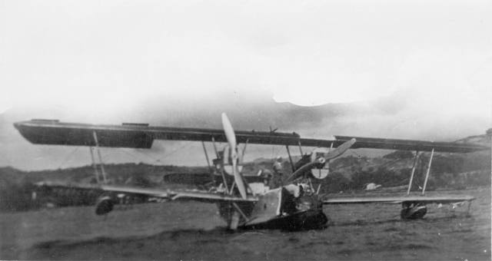
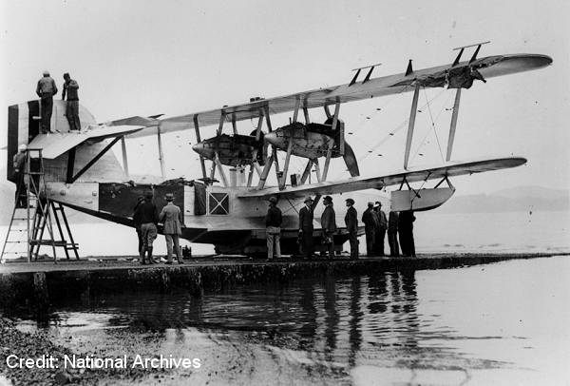

The planners apparently gambled and assumed that tail winds in the form of the required northeast trades would give a 15-percent increase in speed over the route, thus providing the necessary margin of safety for the range.

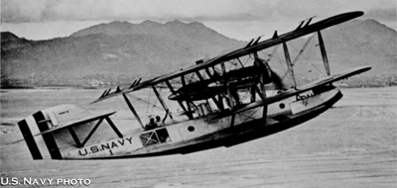

Under the command of Commander John Rodgers, the two PN-9s left San Francisco in the early afternoon of August 31, 1925. On the day of the flight, the PB-1 wasn't ready. In addition to Rodgers who served as navigator of the PN-9-1, four other men were in the crew: Lt. B.J. Connell as senior pilot, two enlisted pilots, Kiles R. Pope and W.H. Bowlin, and Radioman 1st Class Otis G. Stanz. The PN-9 carried 1328 gallons of fuel at roughly seven pounds per gallon amounted to 9298 pounds, while the five crewmen added roughly another 850 pounds. One of the pilots later recalled that "We were so heavy we had to fly 50 miles before we could climb to 300 feet." PN-9-3 suffered an engine oil leak about 300 hundred miles out, landed at sea, and was towed back to San Francisco. The remaining PN-9-1 flew on alone with John Rodgers in command.
Ships were stationed at 200-mile intervals along the Great Circle route to Honolulu, providing communication links and potential assistance that was never more than about an hour of flying time away. These ships also provided visual navigational aids by use of black smoke by day and searchlights at night. For radio navigation the ships had direction finders with which to take bearings on the planes. The two ships stationed nearest to Hawaii were capable of refueling the planes if necessary.
At about the halfway point, the crew realized that their average ground speed had only been 70 knots and the anticipated trade winds had not materilized. Their fuel consumption was greater than anticipated. Cmdr. Rodgers knew that he would have to land and refuel the plane at some point. However, encouraged by improved speeds nearer the Hawaiian Islands, John Rodges bypassed the nearby station ships and decided to fly closer to Hawaii.
At this point, several miscommunications and miscalulations began to build upon each other. With fuel running low, the commander of the PN-9-1 requested radio position finding from the closest naval ship. John Rodgers was apparently confused by the radio position reports and concluded that he would have to depart from his course to find the ship. He turned north, looking for the ship. In reality, the ship was south of him. Rodgers circled in the PN-9-1, hoping to find the ship that he believed was somewhere below him in the squally weather. At 4:09pm the engines quit; the plane had run out of gas. During the glide, the reduced airspeed of the plane caused the wind-driven generators to quit making power, thus shutting down the radio transmitter. The PN-9-1 was able to make a smooth landing in the rough sea. Rodgers had set down on the ocean about 450 miles short of his goal. The plane came down at sea after flying 1841 miles, a new non-stop distance record. At 4:15pm on 1 September 1925, the fliers became sailors.
The crew was not alarmed at first, they thought they would be rescued soon, it did not occur to any of them that they might be in the water for a long time. They believed that ships were close and they were confident that it was only a matter of a few hours before they would be found. The plane's radio operator jury-rigged an antenna on the wings and was able to hear messages from the ships, but was unable to transmit. At the end of a few hours it became apparent that the ships were indeed searching for them, but it was also clear that they were looking in the wrong place. The Navy mounted a massive and intense search for the plane and crew. All the ships along the route were dispatched to the area, and a large group of submarines was sent out from Hawaii. The search conducted by the Navy assumed that the plane was drifting at about eight knots towards the Hawaiian Islands. The plane was actually drifting at about three knots and as a result of this miscalculation the search was moving westward all the time, well out ahead of the plane. It was also assumed that the drift of the plane would be generally along the original trackline or farther south, making Maui or Hawaii the likely islands for the plane to reach. Again, in reality, the plane was farther north, drifting toward Kauai on the western end of the island chain. The PN-9-1 had vanished into the great Pacific Ocean.
Life aboard the floating plane was grim. Surprisingly, little food and water was aboard. All food and water ran out after four days and the crew became weak and dehydrated as they drifted west. Dispite the situation, the crew became very resourceful to survive. After a day or so of drifting, Rodgers and his men began to think about a more extended stay in the water. Rodgers ordered that fabric on the wings be removed and rigged as a primitive square sail between the engines. The crew devised a still using wood from the wings as fuel to distill water, but it only produced about a quart of water. The crew also rigged lee boards from flat metal floorboards in the hull to make steering easier, however marginal steering capability prevented the aircraft from reaching the much nearer island of Maui. On the evening of the seventh day of the ordeal, lights were spotted in the distance and morale improved aboard the plane for the first time since landing.

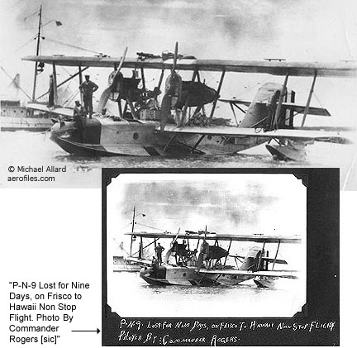

Rescue was near on the eight day of the ordeal. In the morning, the profile of Oahu was clearly visible about 50 miles away. Later that same day the crew was able to collect rain water from a squall and the physical condition of the men improved dramaticly. The crew steered towards Kauai because they believed that it was their best chance of reaching land. On the moning of the ninth day, Kauai was directly ahead of them only about 15 miles away and they made plans for making a landing. As they drew near they tried signaling by waving fabric and burning oily rags in a bucket to attract attention. The plan worked, within a few minutes the submarine R-4 (SS 81) appeared in the Kauai Channel and rescued them. John Rodgers and crew stayed with their plane until they were safety towed into the port of Nawiliwili Harbor on the Island of Kauai. John Rodgers and his crew received a hero's welcome in Hawaii. At the ensuing celebration, Cmdr. Rodgers handed Governor Farrington the first letter to arrive in Hawaii by air. With that action the ambitious flight came to an end.
The Navy’s attempt to reach Hawaii from the West Coast is considered by many historians to have been premature. The Navy did not complete the mission as planned, but it did learn some valuable lessons. Commander John Rodgers did achieve a remarkable feet. He navigated to within ten miles of Kauai, the seaworthiness of the new all-metal hull and the seamanship of the crew were clearly demonstrated. Many lessons were learned including: the need for better fuel planning, the assumptions about the weather conditions, the need to stock adequate emergency provisions, the requirement for improved radio equipment, the dependence on bearings obtained from the radio direction equipment, and lastly was the overly optimistic estimates of the drift of the plane, which meant that the Navy search efforts were always well ahead of the PN-9-1's position.
Although the demonstration fell short of its objective, it served to draw the public’s attention to the depressing state of naval aviation and, in June 1926, resulted in effective legislation to increase the Navy’s air arm to 1,000 planes over the next five years. Further experimentation over the next decade would result in a flying boat capable of reaching Hawaii from the West Coast, as well as demonstrations of massed flights of patrol aircraft throughout the Pacific Rim, extending patrol aviation capabilities closer to Japan.

The airport now known as Honolulu International Airport originally took the name John Rodgers Field. In 1925 the Honolulu Chamber of Commerce raised $20,000 and the City of Honolulu appropriated $45,000 for airport construction. The new airport was named John Rodgers Field in honor of the aviator. As Hawaii slowly forgot this incredible feat, the Rodgers name was dropped in 1947, instead the main terminal building was named for him. More recently, the name John Rodgers Field was used along with the Hawaiian name Kalaeloa when referring to the former Barber's Point Naval Air Station. So, when you see the initials JRF used for Kalaeloa, think of five brave Navy men sailing a seaplane across the Pacific.
In recognition of his sterling qualities as an aviator and his ability as a seaman and navigator, he was appointed assistant chief of the Bureau of Naval Aeronautics until he was killed in an airplane crash in the Delaware River near the Philadelphia Navy Yard on 27 August 1927. The PN-9-1 (A-6878) aircraft was subsequently repaired and returned to service within a week as a token indication that the flight had succeeded. The aircraft did a repeat performance in 1928 while on a flight to South America. Engine problems forced it down in the Caribbean, where pilot Byron Connell and crew drifted for several days before being rescued. Because the towing distance to shore was too great, the plane was dishonorably sunk by gunfire as a hazard to navigation.
Rodgers and Crew in Hawaii

