Big Island Bomber

By Dave Trojan, Hawaii Aviation Historian, story updated Oct 2010

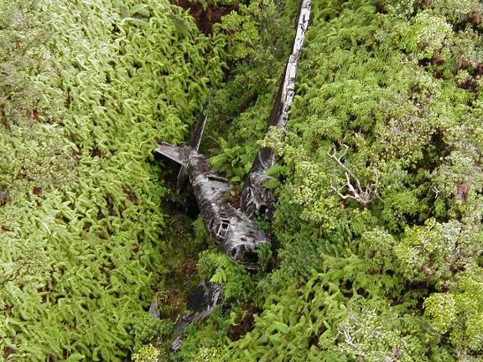
WWII era B-18 Bomber wreckage on the Island of Hawaii Oct 2000 photo courtesy hoagy.org

This B-18 “Bolo” Bomber, serial number 36-446 crashed Tuesday, February 25, 1941. The aircraft with six crewmembers aboard was flying as part of a four aircraft group on a routine instrument night training flight assigned to the 50th Reconnaissance Squadron, 18th Bombardment Wing from Hickam Field. The aircraft were flying at different altitudes and vectors to avoid a mid-air collision, but maintained radio contact. Aircraft serial number 36-446 was flying at approximately 10,000 feet in the vicinity of Hilo on the north shore of the Big Island of Hawaii when a bearing failure caused the loss of the port engine. The pilot, Captain Boyd Hubbard (later Brigadier General; 1912-1982) then attempted to reach Suiter Field on the northwest tip of the island. All possible fuel and cargo was jettisoned, but the aircraft was too heavy to maintain altitude on one engine. As the aircraft descended the other engine began sputtering. The crew believed they were over the ocean at the time in heavy fog during the dark night. The pilot made a last split-second correction prior to the crash. As he later described it, the mountain just loomed up before him in the darkness and he just reacted. He pulled back hard on the wheel and the aircraft stalled out and belly flopped into the thick underbrush. The undergrowth was so dense the plane settled into it and did not slide forward very far. The crew felt the plane hit the tops of some trees and skid for about 75 yards before coming to rest hanging over Punalulu gulch at 10 pm on the side of the Kohala volcano at about the 3500-foot level. They were 13 miles short of the alternate airfield at Upolu Point.
The crew was shook up, but miraculously only one crewmember suffered a minor injury. Following the crash the crew made sure that all power to the aircraft was turned off and then tried to get some rest. During the night the crew endured cold and rain in total darkness. One airman who was riding in the bombardier compartment, located in the aircraft nose section, opened the lower hatch and tried to lower himself out to find his feet did not touch anything solid. He pulled back inside and warned the rest of the crew to not attempt dropping out of that hatch until daylight. The next morning they discovered the plane's nose section jutted out over a 75-foot deep ravine. The crew later described the crash as a “miracle escape.”
On one of the other B-18s in the group was Lee Webster, a Flight Engineer, on his first night navigation mission. Lee Webster gave this account of the accident, “I was just becoming accustomed to the eerie feeling of night flying by the time we started our second leg of the triangle toward a point somewhere off the northern tip of the island and to this point radio contact led us to believe we were in good shape. Suddenly that was shattered by a report from one of the other planes having engine problems and then soon after a report of engine failure and that they were losing altitude. We immediately broke off our mission to accompany the disabled aircraft into Hilo airport, but to make matters worse we flew into some very bad weather. After what seemed a short period of time we lost radio contact with them and when attempts to locate the lost plane became futile we returned to Hickam Field.”
The next morning at dawn a massive search and rescue operation was launched from Hickam Field using 24 bombers. The aircraft wreck was soon spotted at nine in the morning. Later in the day the downed aircrew received an airdrop from Army planes of blankets, food and hot coffee. Wednesday night was much more comfortable for the crew who spent another night in the tropical forest.
A ground rescue operation was organized from Upolu Point, Suiter Field and started out Thursday morning at dawn. The rescuers followed the Kohala Ditch Trail from Kaukini Camp for 2 ½ hours on horseback, but then had to cut a new trail on foot for eight miles through marshland and heavy brush for another four hours before nearing the crash site. The rescuers fired revolvers into the air and then listened for a reply. They were about to give up, when they finally heard a reply by the crew who used a burst of machine gun fire and colored flares which guided the rescuers to the crash site. The rescue party reached the crash scene at noon. Airmen from Hickam later described the site as the “Worst possible place for a forced landing in the Islands.”
At the time only the bombsight and instruments were salvaged from the wreck. Due to its location, it was decided that any further salvage of the aircraft was impossible. The aircraft later slid into the gulch where it still remains today in a very remote part of the Big Island of Hawaii. Unfortunately over the years people have come in by helicopter and taken everything that isn't nailed down, including a salvage raid to restore the B-18 that is in the Air Force Museum. The wreck remains 'in situ' on the Laupahoehoe Nui LLC property, Hamakua, Hawaii on Kohala, north of Mauna Kea.
B-18 Bolo Bomber, serial number 36-446 was built by Douglas Aircraft as construction number 1747, the last B-18 built in the "36-" series. The U.S. Army Air Corps accepted the plane on April 15, 1938. The aircraft was assigned to the 50th Reconnaissance Squadron (50th RS) and assigned aircraft number 81. It was equipped with R-1820-45 engines, serial numbers 36-394 and 36-567. At the time of its loss, the aircraft had a total of 1,023 hours 15 minutes of flight time.
Although designated a reconnaissance and bomber aircraft, the Douglas B-18 flew other important missions. Hickam B-18s towed sleeve targets for gunnery practice by the coast artillery ground troops of Fort Kamehameha near Hickam Field and Camp Malakole near Ewa Marine Corps Air Station. The targets were attached to steel cables and reeled several hundred feet aft of the aircraft. The flight patterns were flown parallel to the beach gunnery ranges and from a point at sea, flying inland to give the troops an overhead shot. The coastal artillery ground troops practiced firing 30/50 caliber machine guns and were not known for their accuracy. The tow cables were severed by gunfire on more than one occasion very close to the tails of the towing aircraft.
The Douglas Aircraft Company developed the B-18 to replace the Martin B-10 as the Army Air Corps’ standard bomber. The Bolo’s design was based on the Douglas DC-2 commercial transport. During Air Corps bomber trials at Wright Field in 1935, the B-18 prototype competed with the Martin 146 (an improved B-10) and the four engine Boeing 299, forerunner of the B-17. Although many Air Corps officers believed the Boeing design was superior, only 13 YB-17s were initially ordered. Instead, the Army General Staff selected the less costly Bolo and in January 1936, ordered 133 as B-18s. The B-18s were equipped with two Curtis Wright (Cyclone) 1820-45 reciprocating engines. By 1939, although underpowered and with inadequate defensive armament and range, the Bolo was the Air Corps’ primary bomber. The Japanese destroyed 12 and damaged 10 of the 33 B-18s on December 7, 1941 at Hickam Field. The few remaining played no significant role in later operations. By early 1942, improved aircraft replaced the Bolo as a first-line bombardment aircraft. Many B-18s were then used as transports, or modified as B-18Bs for anti-submarine duty.

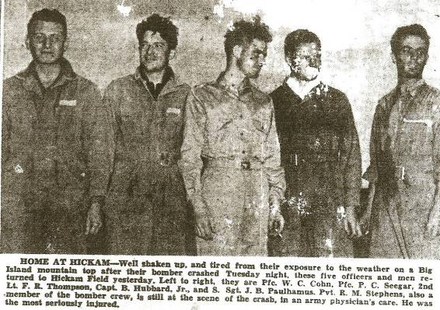
Photo from the Honolulu Star Bulletin newspaper

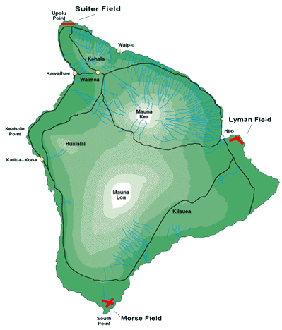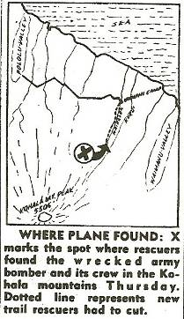
WWII Airfields of the Island of Hawaii Map from Star Bulletin Newspaper
Courtesy hawaiianexpressair.com

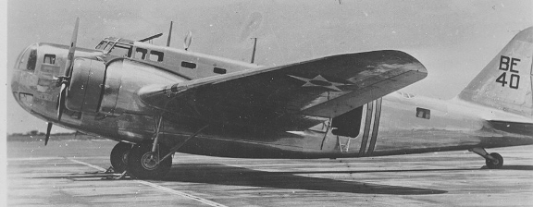
B-18 at Hickam Field, January 1940, 15th AW photo.

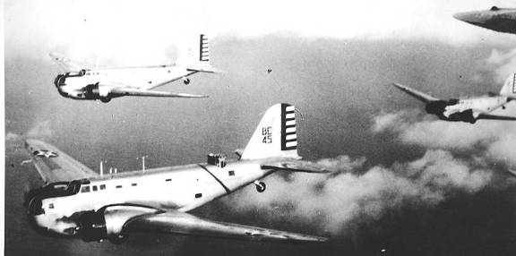
B-18’s with upper turrets extended in flight over Hawaii, 15th AW photo.

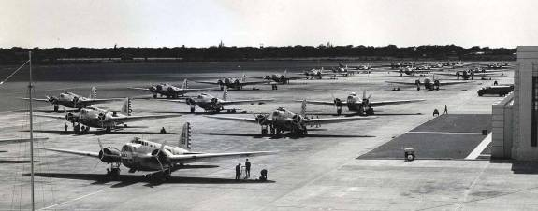B-18A Bolos on the ramp at Hickam being prepared for assignment in the Philippines prior to the start of the war in the Pacific 15th AW photo

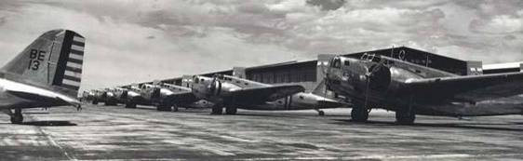
B-18A Bolos on the ramp at Hickam being prepared for assignment in the Philippines prior to the start of the war in the Pacific 15th AW photo

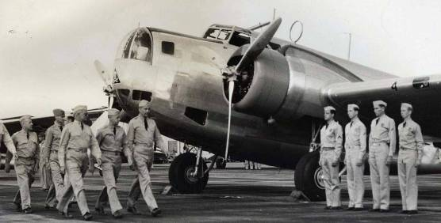
On the flight line at Hickam Field for inspection by Brig. General Walter Frank of the 18th Wing

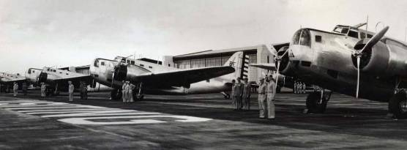
On the flight line at Hickam Field for inspection

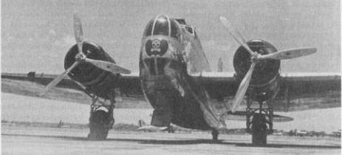
B-18 at Hickam Field with winged death's head insignia of the 5th Bombardment Group on its nose, 15th AW photo.

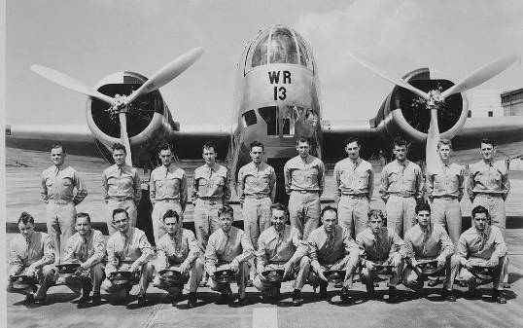
Members of Aircraft Mechanics Graduation Class 2A pose in front of a Douglas B-18 at Hickam Field, 5 June 1940, 15th AW photo.

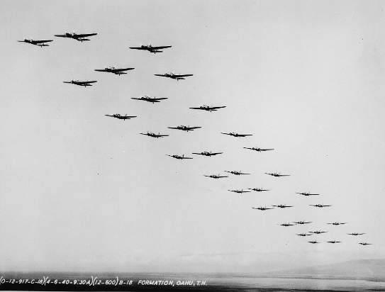
B-18s in formation over Oahu, 6 April 1940, 15th AW photo.

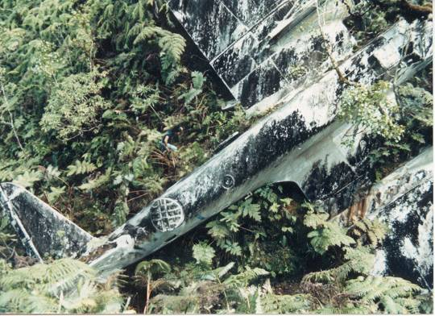
B-18 overhead view exterior photo from AirPirates.com approx 1984

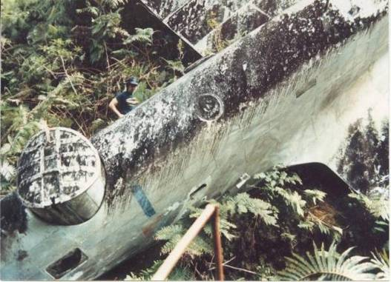
B-18 overhead view exterior photo from AirPirates.com approx 1984

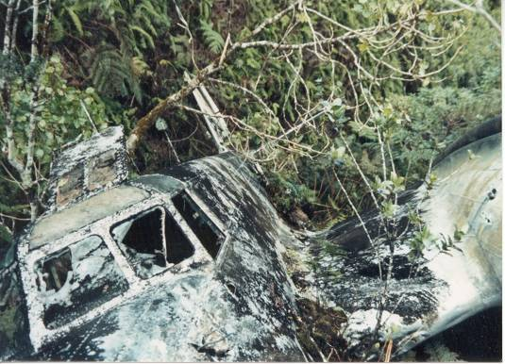
B-18 Front view exterior photo from AirPirates.com approx 1984

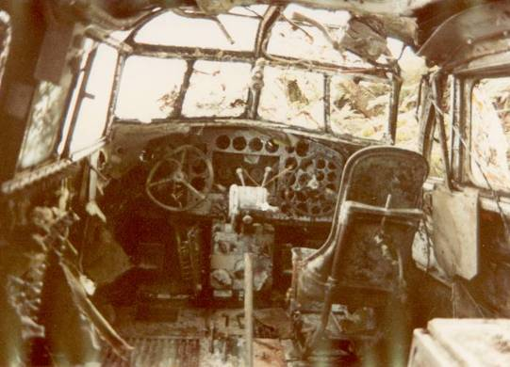
B-18 Cockpit interior photo from AirPirates.com approx 1984

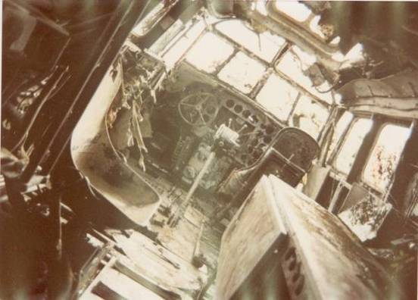
B-18 Cockpit interior photo from AirPirates.com approx 1984

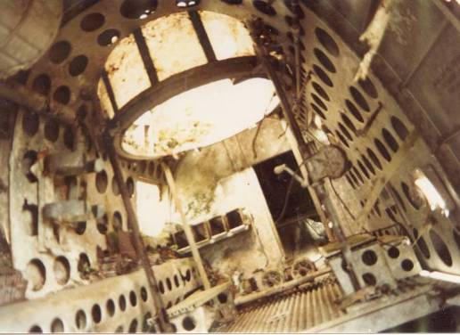
B-18 rear cabin and turret interior photo from AirPirates.com approx 1984

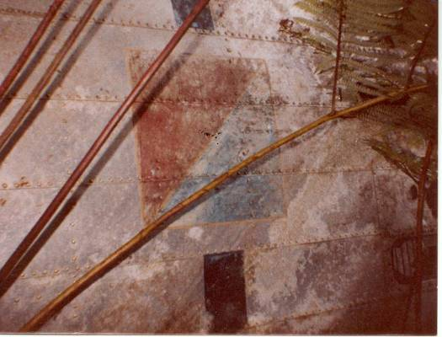
B-18 squadron markings photo from AirPirates.com approx 1984

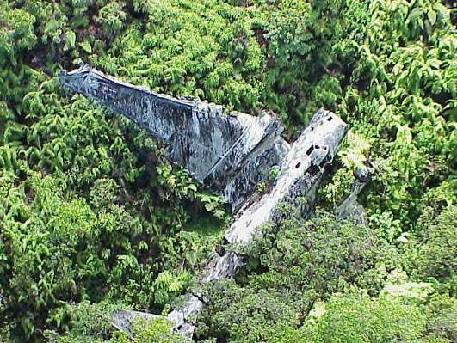
Aerial photo dated 8 June 2004

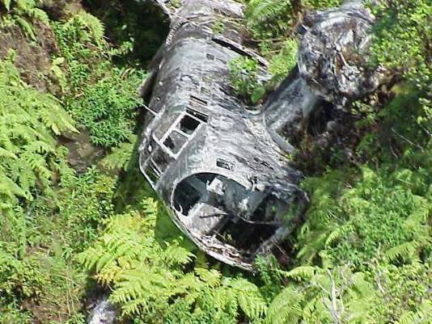 Front aerial photo dated 8 June 2004

